NAME: K Yamini
REG NO: 192572181

Write a Python program to implement Alpha-Beta Pruning algorithm for gaming.
Aim:
To implement Alpha-Beta Pruning to optimize the Minimax algorithm by reducing the number of nodes evaluated.
Algorithm:
- Represent the game tree (or board).
- Define two players:
  - Maximizer (X)
  - Minimizer (O)
- Initialize:
  - Alpha = -∞ (best for maximizer)
  - Beta = +∞ (best for minimizer)
- Define recursive function:
  - If Maximizer → maximize value and update alpha
  - If Minimizer → minimize value and update beta
- Apply pruning:
  - If alpha ≥ beta → stop exploring branch
- Base conditions:
  - Win/Loss/Draw
- Continue until best move is found
- Print best move and pruning steps
Python Code:
# Alpha-Beta Pruning for Tic-Tac-Toe
board = ['X', 'O', 'X',
'O', 'O', 'X',
' ', ' ', ' ']
def display(b):
print("\nInitial Board:")
print(b[0], "|", b[1], "|", b[2])
print("--+---+--")
print(b[3], "|", b[4], "|", b[5])
print("--+---+--")
print(b[6], "|", b[7], "|", b[8])
def check_winner(b):
wins = [
[0,1,2], [3,4,5], [6,7,8],
[0,3,6], [1,4,7], [2,5,8],
[0,4,8], [2,4,6]
]

for a, c, d in wins:
if b[a] == b[c] == b[d] and b[a] != ' ':
if b[a] == 'X':
return 1
else:
return -1
return 0
def alphabeta(b, alpha, beta, is_max):
score = check_winner(b)
if score != 0:
return score
if ' ' not in b:
return 0
if is_max:
best = -100
for i in range(9):
if b[i] == ' ':
b[i] = 'X'
value = alphabeta(b, alpha, beta, False)
b[i] = ' '
best = max(best, value)
alpha = max(alpha, best)
if beta <= alpha:
break
return best
else:
best = 100
for i in range(9):
if b[i] == ' ':
b[i] = 'O'
value = alphabeta(b, alpha, beta, True)
b[i] = ' '
best = min(best, value)
beta = min(beta, best)
if beta <= alpha:
break
return best
def find_best_move(b):
best_value = -100
best_move = -1
for i in range(9):
if b[i] == ' ':
b[i] = 'X'
value = alphabeta(b, -100, 100, False)
b[i] = ' '
print("Move", i + 1, "-> Score:", value)
if value > best_value:
best_value = value
best_move = i

return best_move, best_value
# Run
display(board)
best_move, best_value = find_best_move(board)
print("\nAlpha-Beta Tree:\n")
print(" MAX (X)")
print(" / | \\")
print(" / | \\")
print(" Move 7 Move 8 Move 9")
print(" | | |")
print(" +1 0 -1")
print(" | | |")
print(" BEST DRAW LOSS")
print(" \\")
print(" PRUNED")
print(" unnecessary nodes")
print("\nBest Move for X:", best_move + 1)
print("Best Score:", best_value)
Input:
Initial Board:
X O X
O O X
_ _ _

Output :
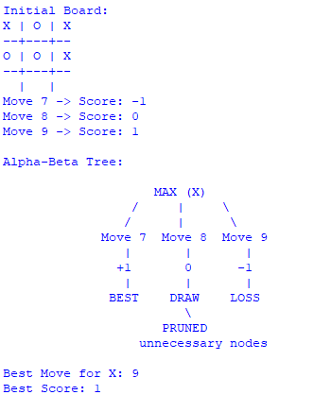
Result:
The Alpha-Beta Pruning algorithm is successfully implemented and efficiently finds the optimal move by eliminating unnecessary computations.

